Hurricane Island is a small Island that is located on the Fox Island archipelago in the Penobscot Bay, Maine. It is around 12 miles away from the Rockland, which is the nearest mainland port city. The total area of the island is 125 acres. Through-out many years the island has changed its concentration. Starting as granite quarrying boomtown and later transforming to a Center of Science, Leadership, and Marine Research (Richardson, 1997).

The Hurricane Island Foundation is a non-profit organization whose mission is to promote science education, applied research, and leadership development through various educational programs and researches. This is a sustainable island community that focuses on experiential sciences, applied research, and sustainable leadership. Therefore, it allows many different students and scientists to participate in the various and authentic research projects. There are different level collaborators in each research project, such as high school students, undergraduate inters, graduate researchers, scientist, etc.

The Hurricane Island Center for Science and Leadership (HICSL) is a scientific and educational community that is located on Hurricane Island. HICSL provides experiential, firsthand research opportunities that concentrate on marine sciences, STEM field, ecology, citizen science, etc. One of the goals of the HICSL is to promote science and make people excited about science and their scientific discoveries as well as environmental conservation. (Science for Everyone, 2014)

There are many programs that held during the year on Hurricane Island, which unites many people and provide them with a scientific research to collaborate. However, during the off-season the staff members work with teachers and students to enhance the program for the project-based science and leadership education in the classroom format (The Hurricane Island).

As was stated earlier, there are various research programs are taking place on Hurricane Island by Hurricane Island Foundation (HIF). For example, in June of 2013, HIF alongside various community members and local scallop fishermen organized a collaborative research. The purpose of this research is to understand how the small-scale closed areas might affect the growth and sustainability of the scallop&#39; s population. The project was initiated with Midcoast Maine scallop fishermen who decided to close a small area in order to harvest scallops for three consecutive years (Science for Everyone, 2014). This research project brought together diverse group of collaborators from both sides. Placopecten magellanicus was the type of scallop that was researched in this particular project. This is an important economic resource for Fishermen in the bays of North America. Therefore, the growth rate estimate is important information to know (Knotz, 1984). Students, scientist, and fishermen were working alongside to set specific equipment, collect data, and perform various analysis based on that data collected. Therefore, students were exposed to the real science research experience and had an opportunity perform something meaningful.

The main purpose of this research was to collect useful information about Scallops. However, it also benefits other parties, such as recruitment of students who could potentially join the scientist community and help with different sustainability issues. As stated previously, collaborators performed various research growth studies on Scallop and these all came from cooperate research with Fisherman of choice, which studied specific close area.

We have around five excel sheets of dataset:

1) 2018 Spat data

2) MR&OP Scallop Spat Bags

3) ScallopGrowth_2016-17_TaggedCage

4) Temperature2_2016_TaggedCage and

5) Temperature2_2017_TaggedCage

The data contains

- Spat data: 17 Columns and 22 rows

- Temperature: 15024 columns and 3 row each in 2016 and 30045 rows in 2017 data.

- ScallopGrowth: 7 excel sheets containing raw data, height, width, depth information

There are various things we gathered from our research and the available datasets we have. And tried to analyze the areas where the scallops are present and how the scallops are cultivated in those area. There are many factors that affect scallop growth like temperature, location, closure zone, density and so on by these factors we will be analyzing how the scallop growth happen in certain area, which is best location for their growth, how the temperature affect the growth, which area the scallop are dying the most, what is the suitable latitude and longitude of certain area, what should be the suitable water temperature and many more.

There are three important dataset we got from the client with the help of which we are doing the analysis of scallop growth. The dataset we have are Spat bag, Scallop growth and Temperature data.

The details of these basic dataset are as follows:

Spat bags Data: Spat is basically the small baby scallop which is recruiting to an area. This is a planktonic stage for scallop which helps us understand what population dynamics are in an area, it also gives us an idea of recruitments to that area. Spat data are from north of the closures, south of the closures and within the closure. The data are from the years 2016, 2017 and 2018.

Based on data present with us the average height of cage 1 scallop in Oct 2017 was 24.87 and cage 2 was 43.7333. This was Random Sampled Measurements of 20 Individual scallops taken randomly. Also, the annual average growth (mm) of the scallops for the years 2016-2017 is approximately 20.86, with this data we can check for further variation over the following years.

This data will help us understand which area is good for settlement around the closed area. Spat data is also gathered from ocean point area which is another closed area, but a larger closed area for long term which has been managed by Department of Rain fishery.

Scallop growth data: Scallop growth data is about growing scallops which are involved in aquaculture research. This data set is used to understand the impact of different gear types on the growth rate of scallops. Scallops have been put in different type of gear and cages and the size of scallops are measured every year, month and some time by weekly. By doing this measurement we can understand the impact of density and gear type on scallop growth.

All the scallops are tagged, to differentiate them from one another which also help to follow their growth as an individual throughout their lifetime in the cages where scallops are grown. The decisions can be taken based on the growth rate analysis.

Temperature Data: Temperature data are some from spat bags which were deployed, and some are from gear and cages which is deployed in Hurricane Island. The variables present in temperature data help us understand spat, population dynamic, popular influences on growth rate of scallops. Also, the temperature of water can be obtained from the temperature data.

In the current research data, we tried to analyze the growth and the size of each scallop in the different closures. For our sample, we got the total Scallop Counts across 2018, 2017, 2016, and 2015 year. According, to the result we gathered, and the calculation provided, the total counts of Scallops actually decreased from 2015 onwards. The first graph shows that the Scallop distribution across the years. We decided to use bar chart to represent scallop growth divided by years. In the second data sample, we took the counts of total scallops across different closure zones. Based on the analysis, we noticed that the distribution was not even. First closure has far more total scallops counts compare to the south and the north. As far the graph we decided to show bar chart dividing scallops based on the zones.

I have done some research on methods used for scallop’s growth. I also gone through some research articles where I gathered some idea regarding scallop growth and methods used.

Following are the R plot through which we tried to answer few of the research questions:

1) Our First research is to find the Scallops in each closure zone in the most recent year and compare those with each closure zone as which zone has the most scallop growth and which has the least.

In this data sample, we took the counts of total scallops across different closure zones. Based on the analysis, we noticed that the distribution was not even. First closure has far more total scallops counts compare to the south and the north. As far the graph we decided to show bar chart dividing scallops based on the zones.

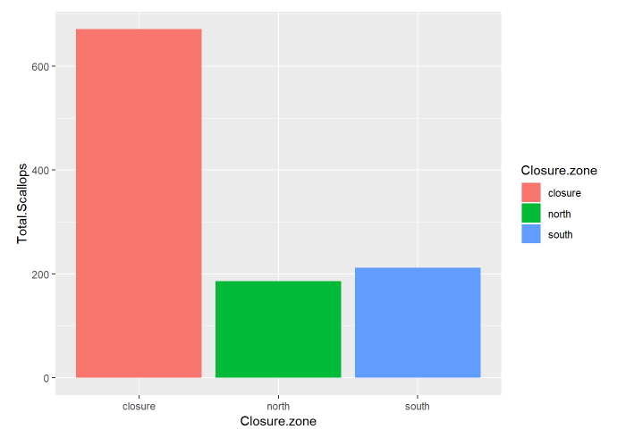

ggplot (spatbag, aes(x=Closure.zone, y=Total.Scallops)) + geom_bar(stat = "identity")

2) Our Second Research is about Scallop Count per Year. So for this research, we wanted to analyze the growth and the size of each scallop in the different closures.

In the current research data, we tried to analyze the growth and the size of each scallop in the different closures. For our sample, we got the total Scallop Counts across 2018, 2017, 2016, and 2015 year. According, to the result we gathered, and the calculation provided, the total counts of Scallops actually decreased from 2015 onwards. This graph shows that the Scallop distribution across the years

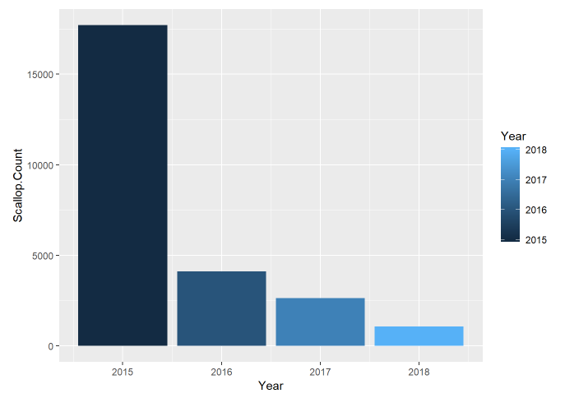

Ggplot (spatstats, aes(x=Year, y=Scallop.Count)) + geom_bar (stat = "identity")

3) Scallop Counts in each Area

According to our Analysis Muscle Ridge Area have had maximum count of scallops for 4 consecutive Years.

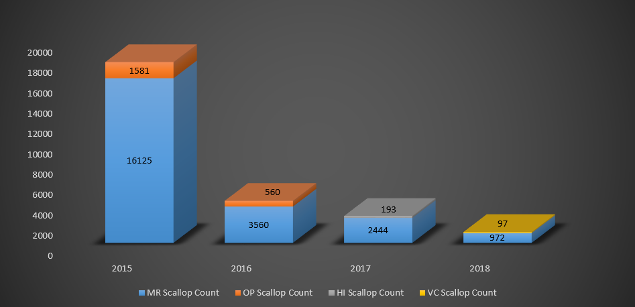

4) Temperature Drop in 2017

In 2017 Average temperature drop was more than 2 degree Celsius which might have impacted Scallop Count.

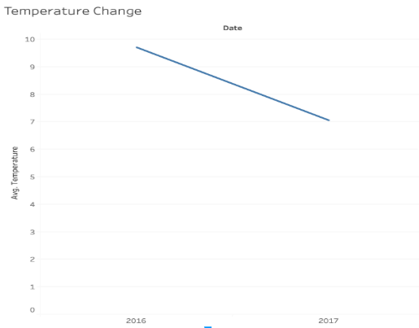

5) Increase in Scallop Size

Average Scallop Size in 2017 increased from 1.2 cm to 1.5 cm.

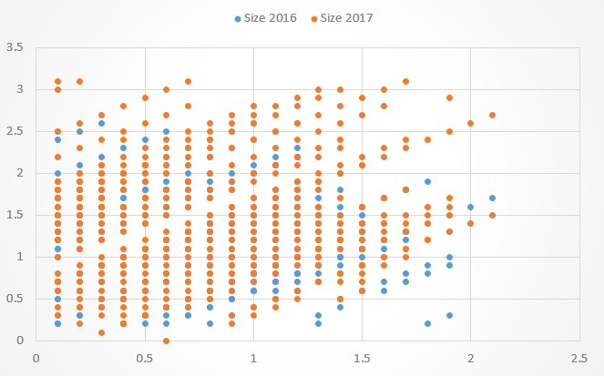

There are few traditional methods that need further analysis in order to better understand the growth rates of scallops.

Ear-hanging is one method that can be used to grow scallops. The technique comes from Japanese scallop farms, where operations are large scale and far more mechanized. This method is used when scallops are about 2 inches. Under this method a hole is drilled in the “ear” or wing of the shell and gets threaded onto a rope that will be suspended in the water column. Ear hanging method is labor intensive process. There are some improved growth rates are analyzed by this method because of water flow and space. There are few other methods like bottom cage also has been used for growth analysis. Ear-hanging is an exciting possibility for Maine waters.

Fisherman closed small area in the muscle ridge to observe and understand what small closure might do for their local Scallop population. This is performed in rotational management strategy, so various places and zones are open and closed during different time. For example, one place can be closed for two years and then open for following year. In the muscle ridge closure, Spats are the scallop&#39;s specie they are researching about. In order to collect data, researches use spat bugs to catch the scallops in the platonic stage and later each of them can be marked with specific colored tag. By doing that, it helps them to obtain basic analysis and understanding the population dynamics and the idea of the recruitment for that area in the future. This successful research would identify areas that are good for settlement around, so it can be maintained better. At the same time, there are different closed areas as well, which are under the watch. Thus, the data collected from various closed areas would potentially be useful in the comparison analysis (Science for Everyone, 2014).

Hurricane Island Foundation also participates in the aqua cultural research and one of the objectives is to understand the impact of different gear types on the growth rate of scallops. Part of their research is to identify the growth data. Based on this project the island research community started to grow own scallops, so then research samples would be available to study upon. One of the methods the community used was to put scallops in the cages and to measure them every month for the entire year. As was stated previously, each scallop was marked in advance to be able to identify them later. Therefore, this would later map to the specific which provides the growth rate. Usage of spat bags allows them to identify the future population density. For example, the spat bags are assembled in the different locations in the beginning of the research based on the results the collaborators may predict which area they should protect for the future (Science for Everyone, 2014).

**Work count: 2032**

Reference:

1. Scallops, and Clams, and Mussels, Oh My! (n.d.). Retrieved from <http://www.hurricaneisland.net/science-for-everyone/2015/7/29/scallops-and-clams-and-mussels-oh-my?rq=bailey> moritz
2. Brzezinski, D. (n.d.). Figure 2f from: Irimia R, Gottschling M (2016) Taxonomic revision of Rochefortia Sw. (Ehretiaceae, Boraginales). Biodiversity Data Journal 4: E7720. <https://doi.org/10.3897/BDJ.4.e7720>. Scallop Enhancement: A Literature Review with a Focus on Methods’ Applicability in Maine Waters. doi:10.3897/bdj.4.e7720.figure2f
3. Cliché, G., Vigneau, S., Giguere, M. (1997). Status of a commercial sea scallop enhancement project in Iles-de-la-Madeleine (Quebec, Canada). Aquaculture International 5(3): 259-266.
4. LEVERONE, J. R., GEIGER, S. P., STEPHENSON, S. P., & ARNOLD, W. S. (n.d.). Figure 2f from: Irimia R, Gottschling M (2016) Taxonomic revision of Rochefortia Sw. (Ehretiaceae, Boraginales). Biodiversity Data Journal 4: E7720. <https://doi.org/10.3897/BDJ.4.e7720>. INCREASE IN BAY SCALLOP (ARGOPECTEN IRRADIANS) POPULATIONS FOLLOWING RELEASES OF COMPETENT LARVAE IN TWO WEST FLORIDA ESTUARIES. doi:10.3897/bdj.4.e7720.figure2f
5. Richardson, E. M. (1997). Hurricane Island – The Town that Disappeared. Retrieved September 25, 2018, from <http://www.hurricaneisland.net/history>
6. The Hurricane Island. Retrieved September 25, 2018 from <http://www.hurricaneisland.net/about-us/>
7. "Science for Everyone", (2014), HIF to coordinate a collaborative research project. Retrieved September 25, 2018, from <http://www.hurricaneisland.net/science-for-everyone/2014/2/26/scallop-project>
8. Krantz, D. E., Jones, D. S., & Williams, D. F. (1984). Growth Rates of the Sea Scallop, placopecten Magellanicus, Determined from The18O/16O Record In Shell Calcite. The Biological Bulletin, 167(1), 186-199. doi:10.2307/1541347